**GENERAL PHYSICS 2**

**PERFORMANCE TASK 1: WORKSHEET**

**Grade, Strand, and Section: 12 STEM 8A______________ ________________________ Group No: 3________________**

|  |  |  |  |
| --- | --- | --- | --- |
|  | **GROUP MEMBERS (enlist names alphabetically and start from the last name,**  **first name, and middle initial)** | | |
| **1** | **AGAG** | **Christian Hanz** | **O.** |
| **2** | **BORJA** | **Dav Vixent** | **L.** |
| **3** | **DE JESUS** | **Carl Enrich** | **P.** |
| **4** | **DELIGENTE** | **Marco Cyrus** | **A.** |
| **5** | **GALVAN** | **Francheska Vittoria** | **M.** |
| **6** | **REYES** | **Jann Reyes** | **T.** |
| **7** | **VALENZUELA** | **Adrian Paul** | **M.** |

**PART 1: FREE BODY DIAGRAM**

**Attach your free body diagram showing the location of each charge in the coordinate system (15 pts total)**

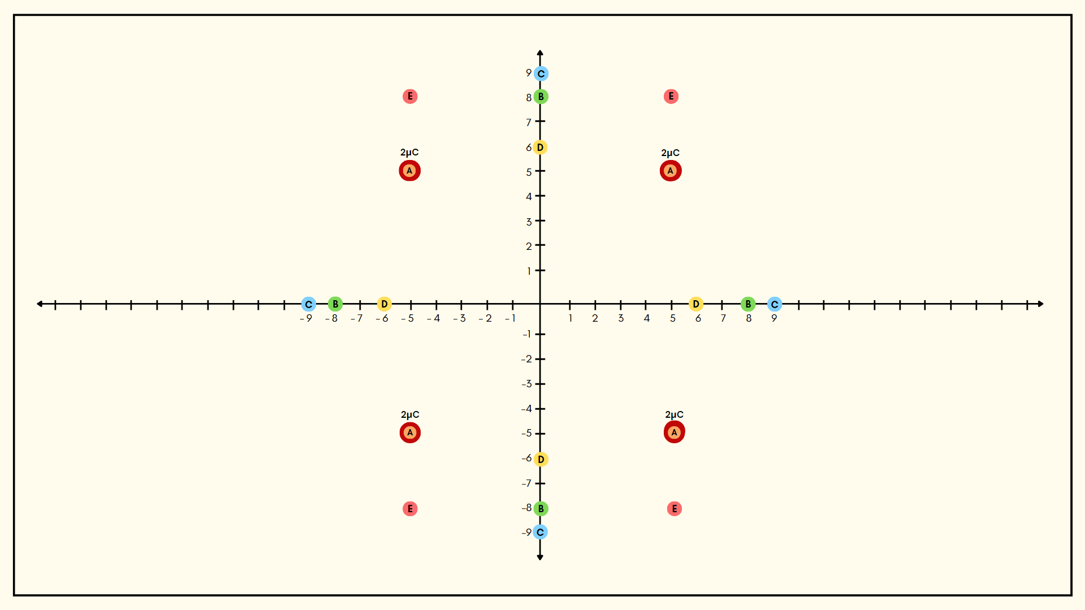

**PART 2.1 PROBLEM SOLVING (Electric Potential)**

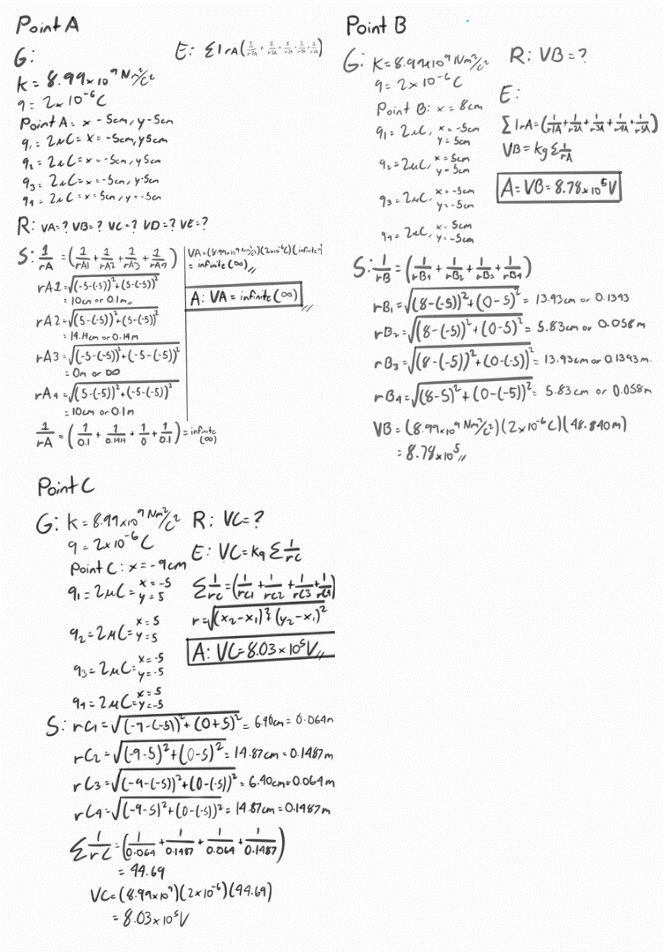

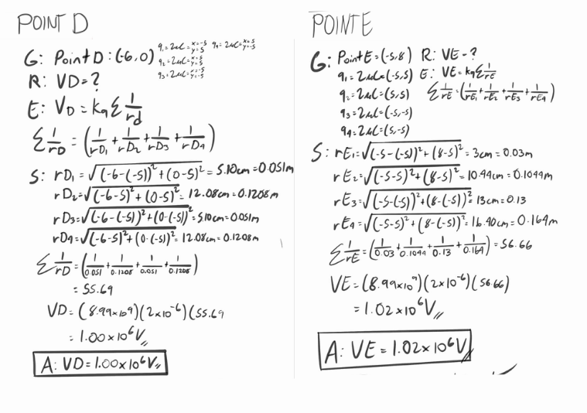

**PART 2.2: PROBLEM SOLVING (Potential Difference)**

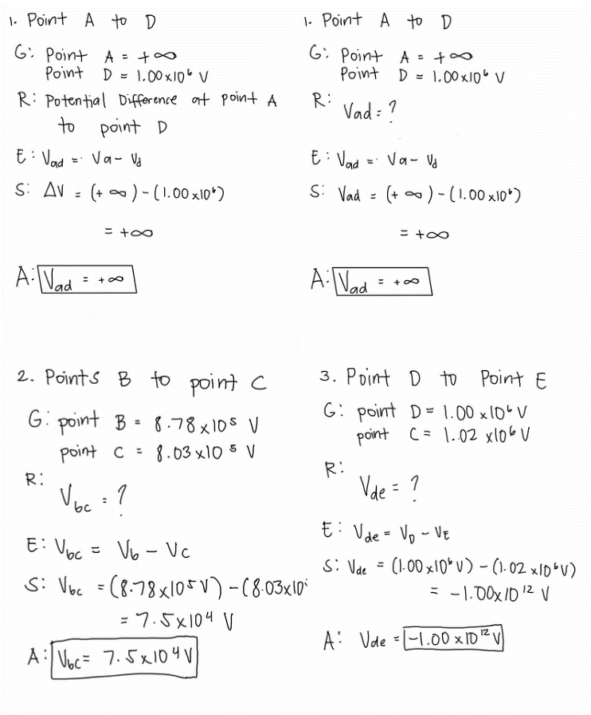



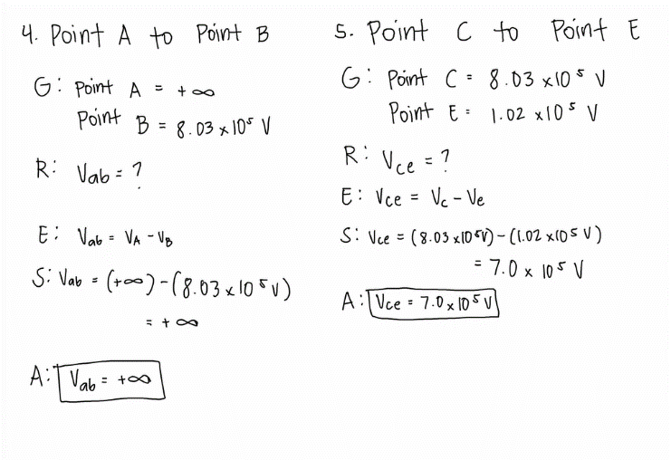

**PART 3: SCALE MODEL OF EQUIPOTENTIAL LINES**

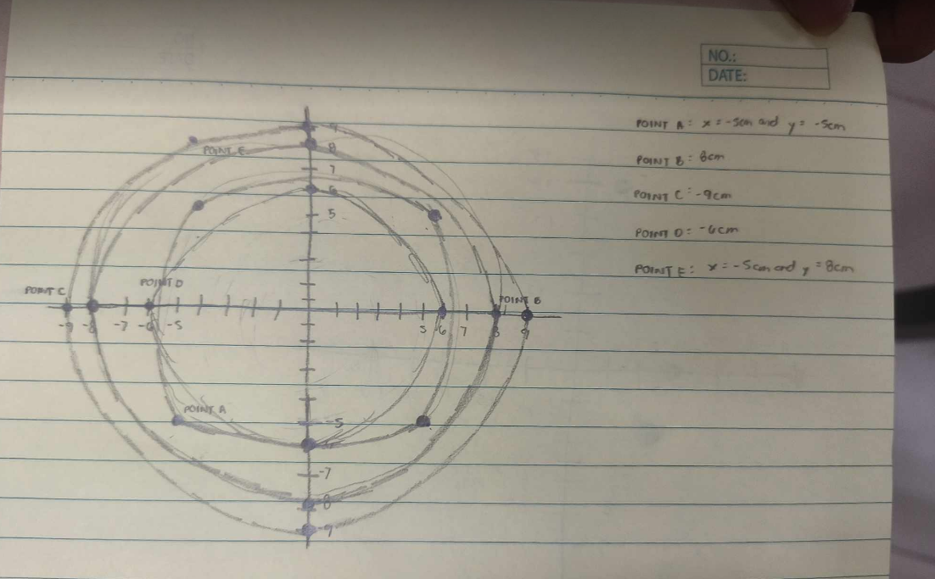

This image is the first layout of the free body diagram. This was made during the group meeting in

physics class. This turns out as our reference in making the scale model and the free body diagram itself.

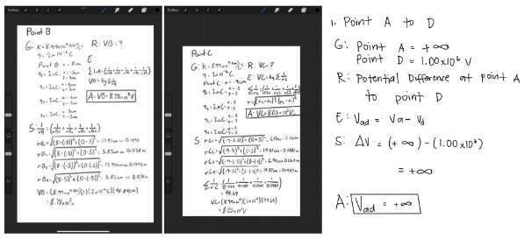

This image shows two of the results of electric potential and potential difference. This is also the computation steps on how to find the potential difference of points A to E. With this we

determined the points needed for us to be able to start and prepare for the making

of the free body diagram and the sketch of the model itself.

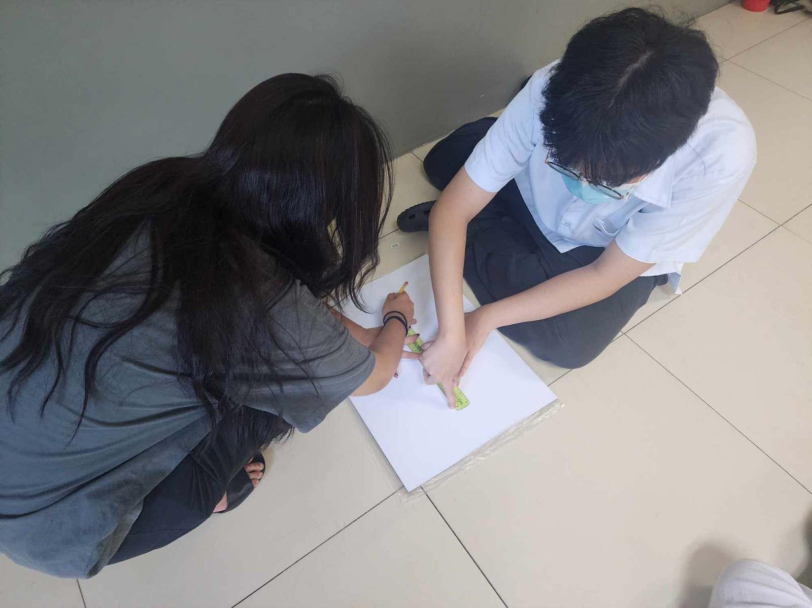

This is the time that the sketch for the scale model starts. With the computations done, the group started

to sketch the results on the illustration board. The help of the ruler is to determine the distance of each line.

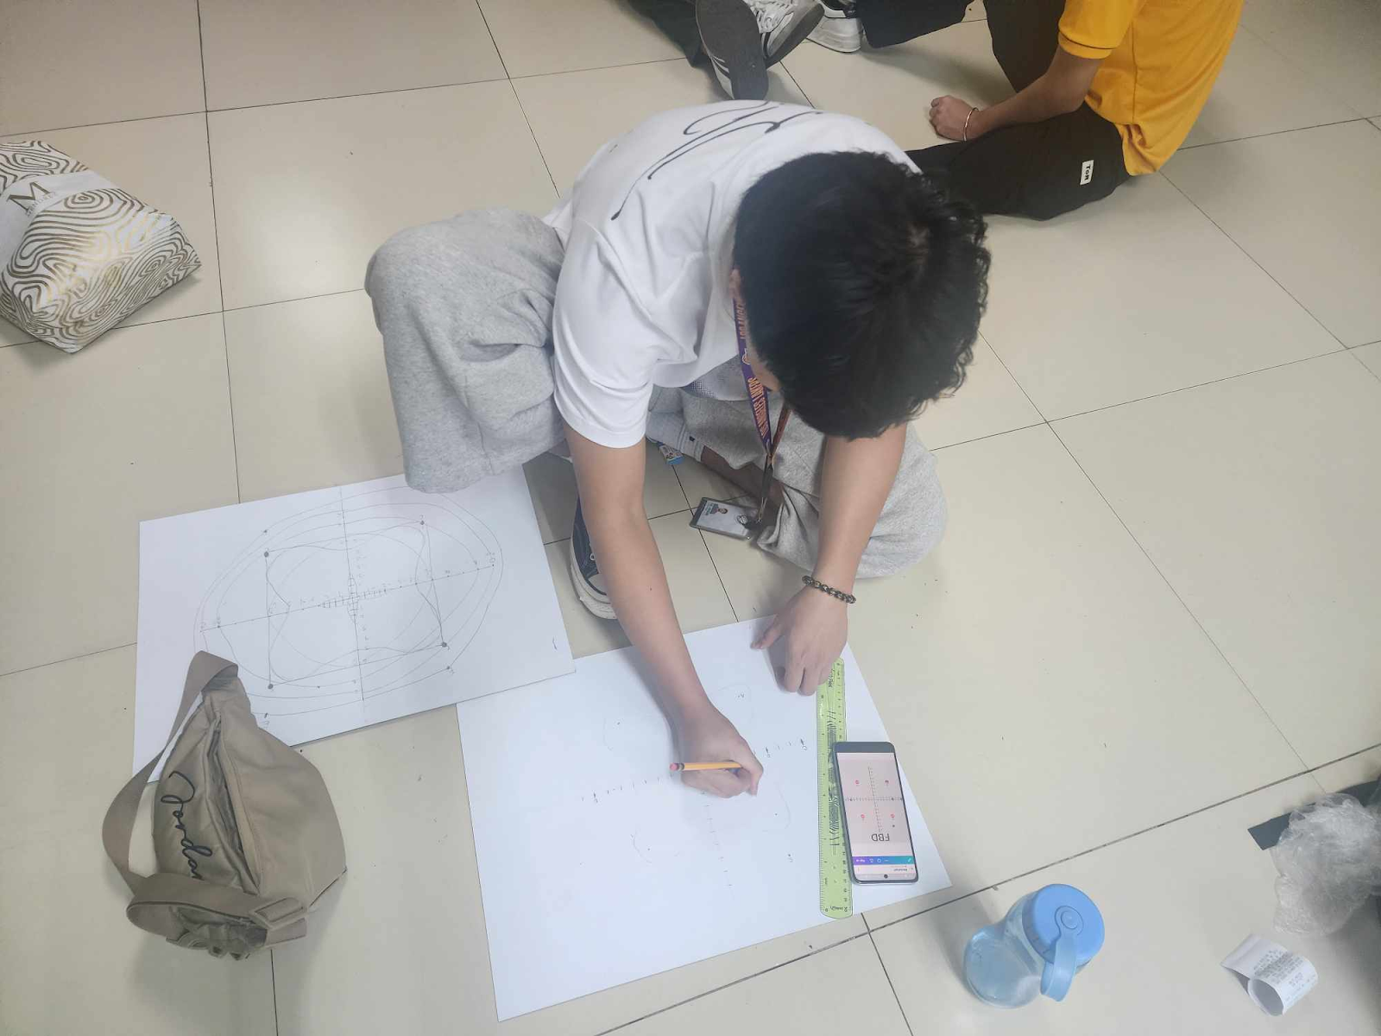

This is the making of the final sketch for the Scale Model. With minor revisions on sketching we finally

made it neat and clean. We again used the ruler for measuring the distance of lines and referred

to the first sketch and the canva free body diagram.

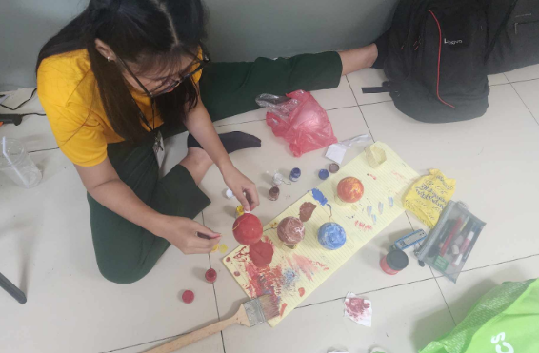

This is the making of the charges in the scale model. We painted it with colors that reference the colors

of different planets and used a brush to give more effects on the colors on the balls.

Making it more visually appealing and gives extra spark.

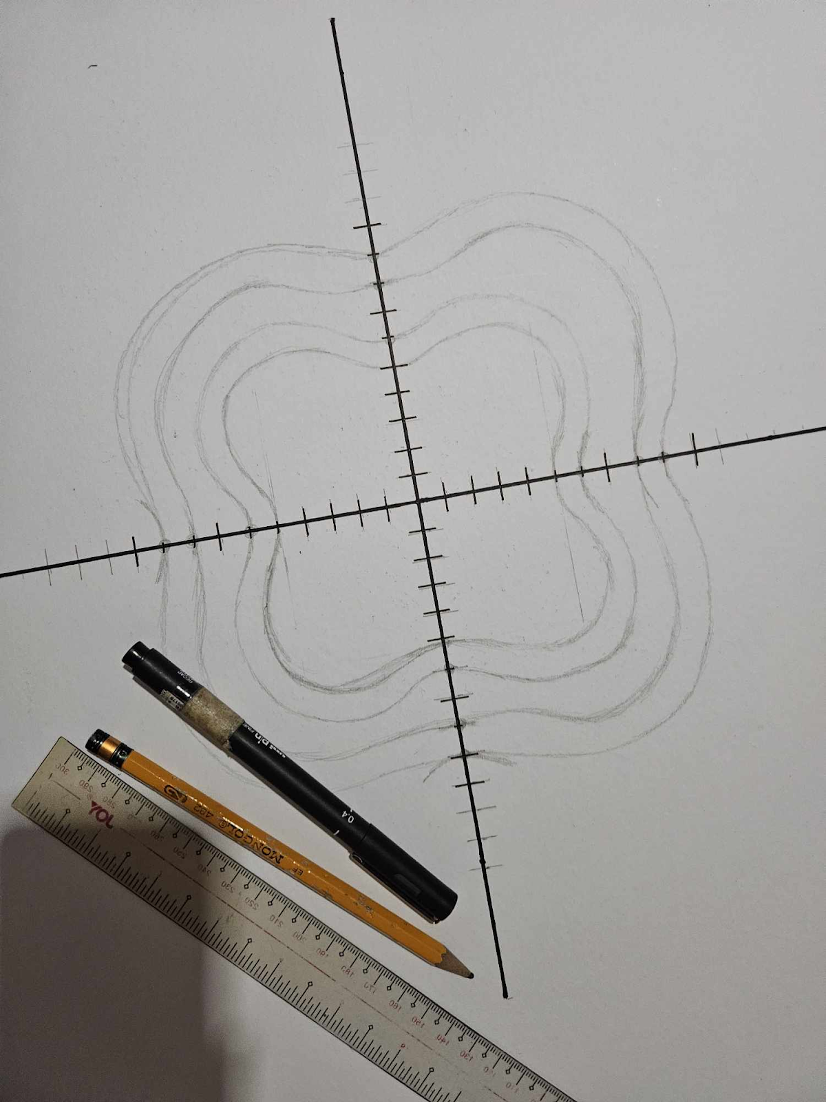

This is the final image of the sketch of the scale model of equipotential lines. This was again double checked to make sure that the measurements were correct. This also went through minor adjustments.

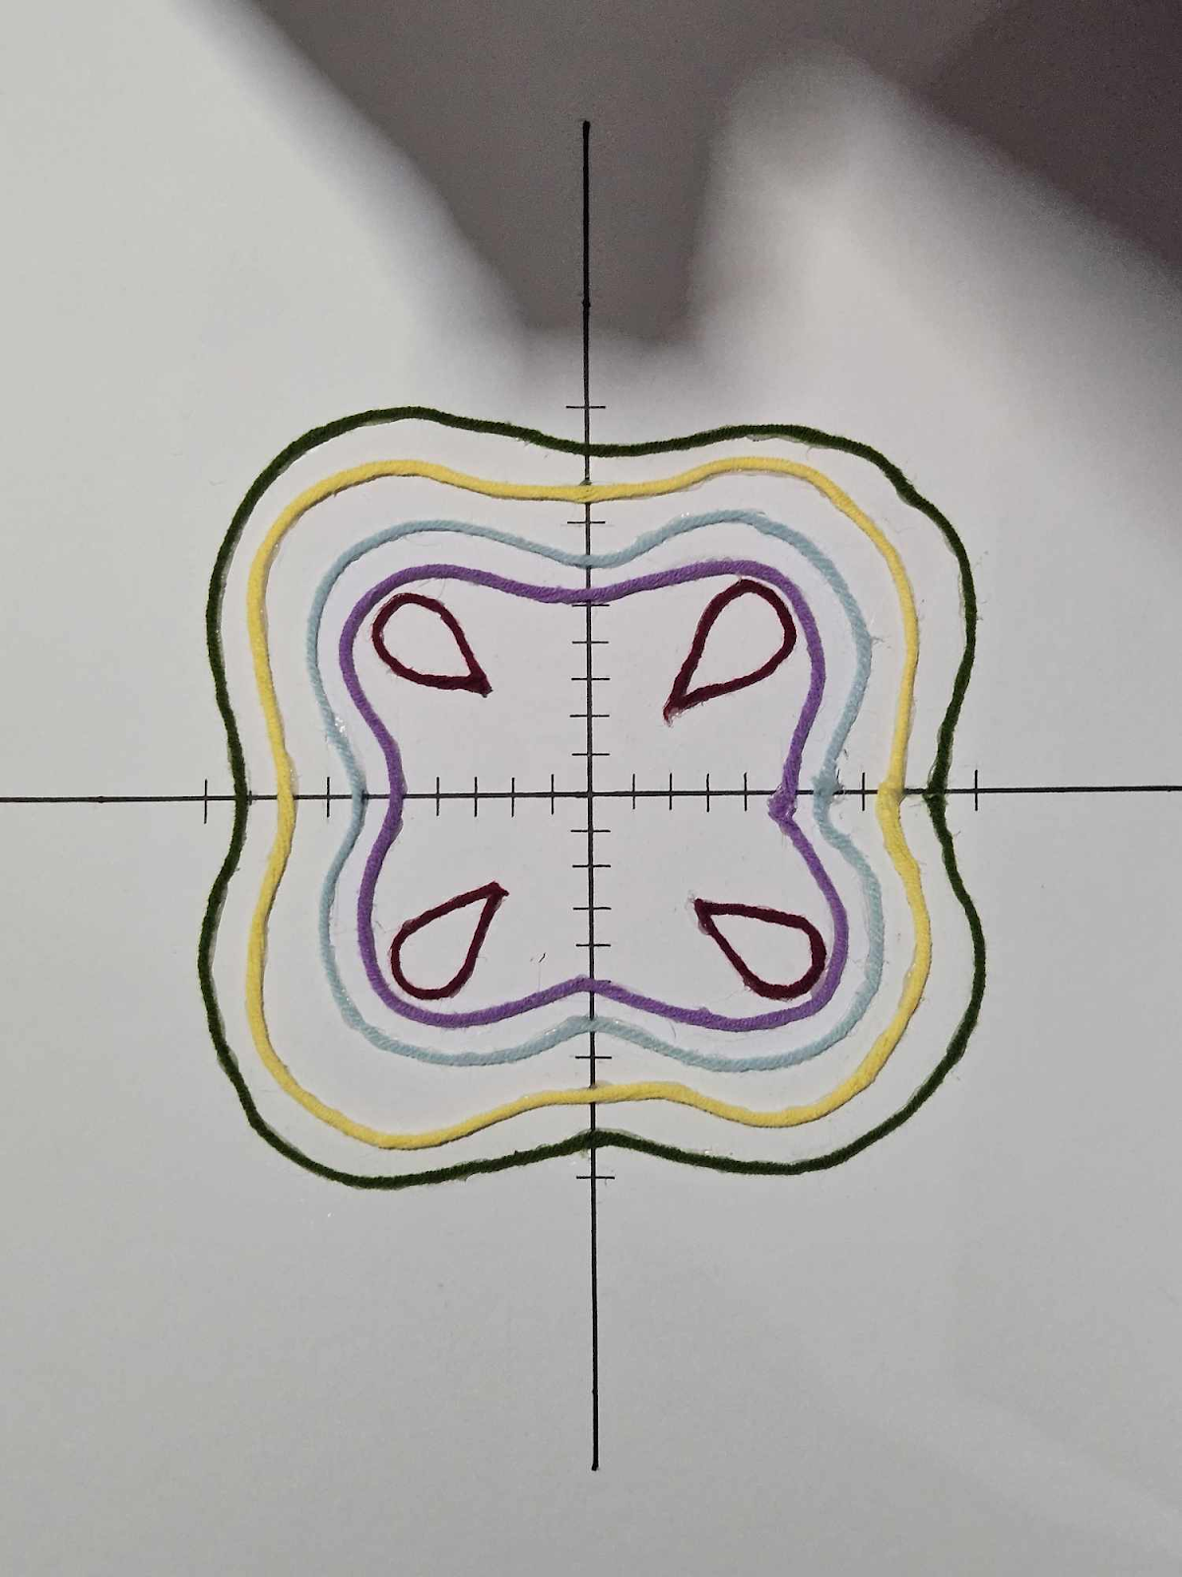

This is the image of the equipotential lines with different colors of yarn. With the help of the glue

gun we were able to attach the yarns with different colors on their perspective lines.

Determining the different values of electric potential.

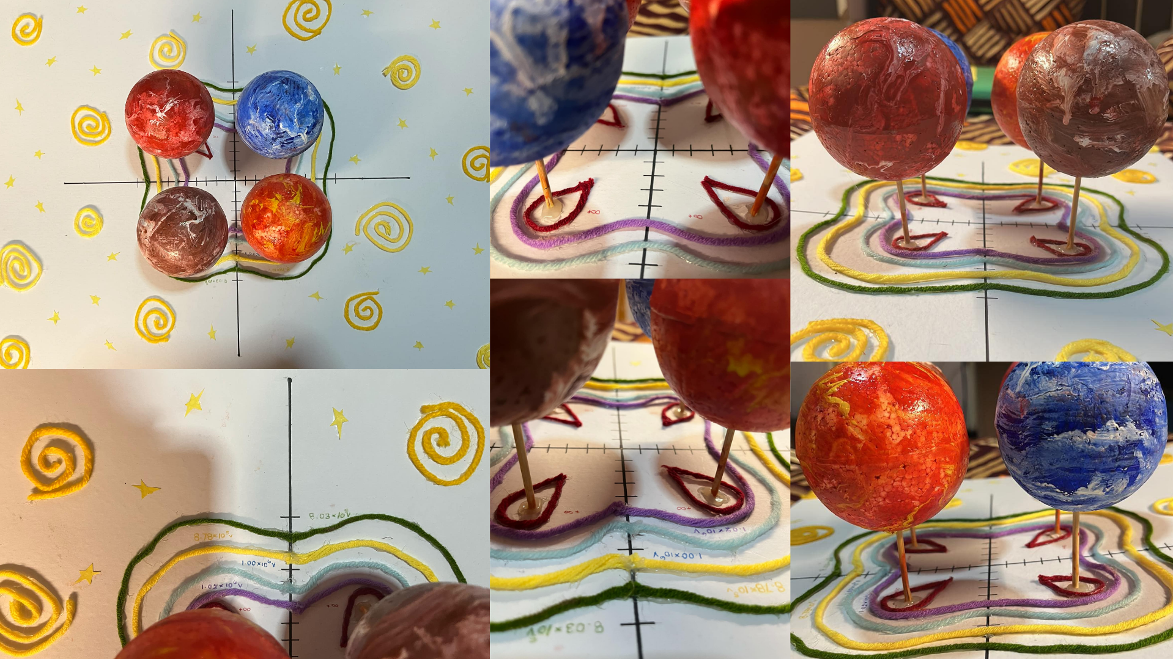

This is the image of the finished Scale Model of Equipotential Lines made by Group 6. Attached are the different colors of yarn representing the equipotential lines and their different values of electric

potential. The styrofoam colored balls determine the charges within the scale model.

Also adding to it are the spiral designs and many shining stars.

**PART 4: Guide Questions**

1. Why is symmetry beneficial in calculating electric potential, and how is this principle applied in designing sensors in telecommunications?

With symmetry, it makes the calculation of electric potential much easier because it is easily determined where the different points are of the electric potential without solving every part of it. With symmetrical shapes, it creates a smoother and much more reliable electric field improving the strength of the signal and reducing interference. Some applications can be found on antennas, satellites and more. One benefit is that it enables electric signals through toxic human environments and hard to reach vehicle components (Tech Briefs, 2018). Another benefit is that researchers takes less time solving problems because of it (Altair Feko, 2025).

1. Why do equipotential lines form specific shapes around distributions of charge?

Equipotential lines form specific shapes around distributions of charge because it shows areas where the electric potential is the same (Hyperphysics,N.d). The charges are arranged based on the Equipotential lines. It is dependent on the electric field geometry. Urone(2012) claimed that between two parallel conducting plates, the equipotential lines are automatically straight and parallel to the plates. And it is also important for grounding and shield applications.

1. Why can we determine the electric potential at multiple points without additional calculations, and how is this method used in geophysics to detect underground mineral deposits?

This is because when a charge distribution follows a simple pattern such as a sphere or etc, finding electric potential can be achieved with only using formulas without having the need to recalculate everything. Because of this, Geophysicists can find minerals underground. This is by measuring the electric potential differences in the ground, finding deposits of metal and water (Environmental Protection Energy, 2024). Sahoo (2023) also claimed that the more precise the calculations are, the more minerals they can find underground. This leads to finding more minerals that can benefit humans.

1. How would the electric potential at the given points change if an external uniform electric field were applied to the system, and why is this principle important in designing lightning protection systems for buildings?

If it were applied, it would change or shift the electric potential from one place to another. This allows for one side to be more negative and the other to be more positive. This is achieved through electrically connecting parts of a building or structure making all of the electric potential same (Kings Mill Industries, 2021). This allows the structure to direct where electric energy can be put to especially during thunderstorms. This allows safety for the buildings and the structural integrity of structures (Csanyi, 2019).

1. How does the spacing of equipotential lines relate to the strength of the electric field, and why is this principle important in designing high-voltage insulation for power lines?

When the space of the lines are much closer together, the stronger the electric field is. But when they are further apart, it gets weaker (Mrchuakh, 2023).This important for the design of electric wires, the insulation helps the electric components to prevent sparking and electrical breakdowns(Arora, 2011). This consideration of designing Electric wires is important for preventing accidents. It is also used in controlling wires within our devices.

**References**

*Computational benefits of using symmetry*. (2025.). (C) Copyright 2025. <https://help.altair.com/feko/topics/feko/user_guide/cadfeko/symmetry_benefits_feko_c.htm?/>

Csyani, E. (2019, March 19). *What is the purpose of equipotential bonding?* Electrical Engineering. <https://electrical-engineering-portal.com/purpose-of-equipotential-bonding#google_vignette>

*Equipotential lines*. (n.d.). <https://hyperphysics.gsu.edu/hbase/electric/equipot.html?/>

Kingsmill Industries UK Ltd. (2021, July 30). *Bonding Guide - Kingsmill Industries*. Kingsmill Industries. <https://kingsmillindustries.com/product-guide/bonding-guides/>

Mrchuakh. (2023, August 13). *12.6.2 Equipotential Lines*. xmPhysics. <https://xmphysics.com/2023/08/13/12-6-2-equipotential-lines-2/>

Sahoo. (2023, April 27). *ELECTRICAL METHODS OF GEOPHYSICAL EXPLORATION OF MINERAL DEPOSITS.pptx* [Slide show]. SlideShare. <https://www.slideshare.net/slideshow/electrical-methods-of-geophysical-exploration-of-mineral-depositspptx/257600574>

*Self-Potential (SP) | US EPA*. (2024, September 25). US EPA. <https://www.epa.gov/environmental-geophysics/self-potential-sp?utm_source=chatgpt.com>

Tech Briefs. (2018, September 21). *A ‘Symmetrical’ approach improves wireless microsensors*. <https://www.techbriefs.com/component/content/article/29072-a-symmetrical-approach-improves-wireless-microsensors>?

Urone, P. P., & Hinrichs, R. (2012, June 21). *19.4 Equipotential Lines - College Physics | OpenStax*. <https://openstax.org/books/college-physics/pages/19-4-equipotential-lines?/>

**PERFORMANCE TASK WORK PLAN**

**PETA #: 1 Group #: 3**

**Subject: General Physics_________________________ __ Date of PETA: March 10, 2025__________**

**Teacher: Lyndon Dela Cruz______________________ Section: 12 STEM 8A__________________________**

|  |  |  |  |  |  |
| --- | --- | --- | --- | --- | --- |
| **No.** | **Member Name**  ***alphabetical*** | **Assigned Tasks**  ***distribute as equally as possible*** | **Level of Accomplishment *check one*** | | |
| **None** | **Partial** | **Full** |
| **1** | **AGAG** | **Model and Materials** |  |  |  |
| **2** | **BORJA** | **Part 2.2** |  |  |  |
| **3** | **DE JESUS** | **FBD and Part 2.1** |  |  |  |
| **4** | **DELIGENTE** | **Part 3** |  |  |  |
| **5** | **GALVAN** | **FBD, Scale Model, and Model** |  |  |  |
| **6** | **REYES** | **Part 2.1** |  |  |  |
| **7** | **VALENZUELA** | **Guide Questions and Model** |  |  |  |
| **8** |  |  |  |  |  |

**AGREEMENT**

**This is to confirm that the task distribution and levels of accomplishment as listed above were discussed and agreed upon by the group. We acknowledge that group members with partial accomplishment will be given a lower score while those with no accomplishment will be given zero and will need to redo the PETA individually.**

**

***Affix signature over printed name:***

***Agag, Christian Borja, Dav De Jesus, Carl Deligente, Marco Galvan, Francheska***

**Member 1 Member 2 Member 3 Member 4 Member 5**

**Reyes, Jann Valenzuela, Adrian**

**Member 6 Member 7 Member 8 Member 9 Member 10**